When you are adding an item to an order, after you select the estimate, you will be prompted with a quoted price selection window.

Typically, you would select the appropriate price and hit OK. However, if you hit cancel, the X in the top right, or hit the ESC key, this window will close without selecting a price.

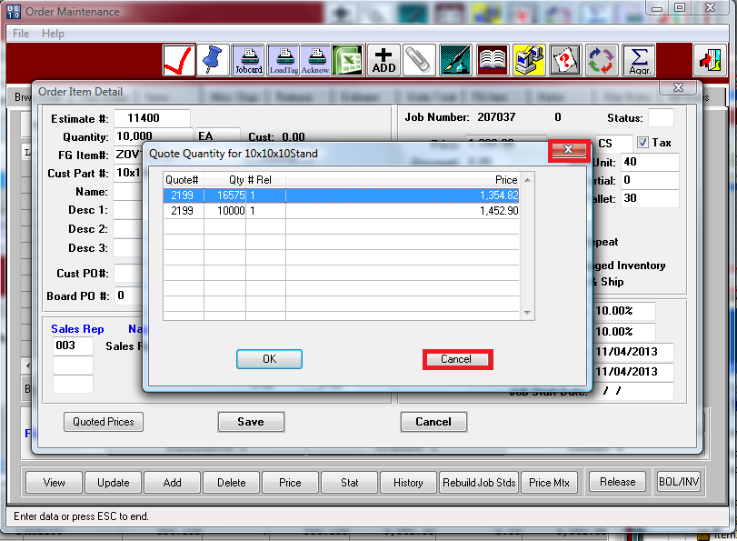

When this happens, the default price from the Finished Good file will be imported.

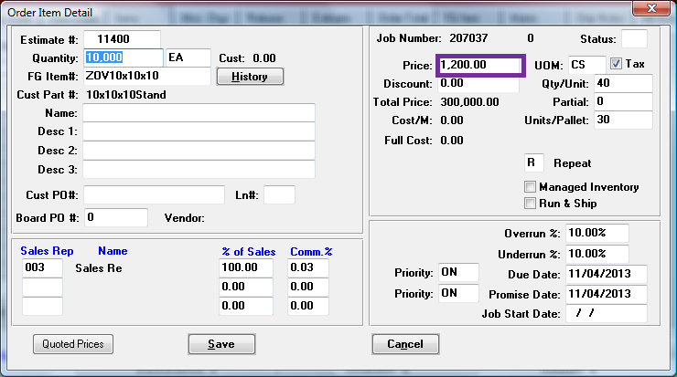

In IF1:

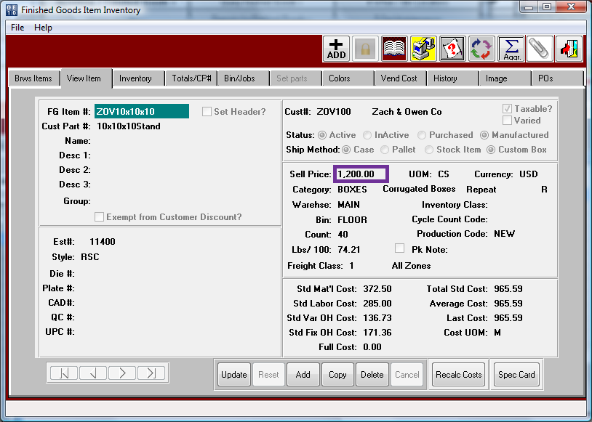

After the next patch, if you notice an order line item saved with a wrong price, you will be able to click on the “Quoted Prices” button in the lower left of the order item screen to select from a list of quoted prices again:

